**Unit 7 Topology Analysis**

Corey Crooks

Purdue University Global

IT331-01

Ahmed Banafa

January 4, 2023

**Part 1**

In an attempt to not waste your time, I’ll be completely honest; I didn’t do the labs this week. Since unit 4, the website isn’t showing me my results for the quizzes so I am unable to fulfill the screenshot requirements for these assignments. But that’s fine! Apparently I’ll end up with between a 75% and 85% in the class with 0 points on part 1 for those assignments according to my math, and I can live with that.

Instead, I would like to take a moment to mention how much this class has helped me in the time I took it. Recently, I’ve learned that the job my friend has as a cybersecurity analyst is getting rid of the bachelor’s degree requirement, and opening up to students interested in Software Programming. Because of this class, I have been able to study key concepts like the OSI model, network topographies, DNS, and various internet efficiency and security related protocols in order to prepare for an interview coming in April! I wanted to say an immense thank you to you for helping me achieve that knowledge, and presenting these concepts in a way that makes it easy for me to grasp, and to learn. Hopefully the work in my assignments have reflected my knowledge growth and independent studies.

If you would at all be interested in following up with me to help me prepare, I would encourage an email at [coreycrooks@student.purdueglobal.edu](mailto:coreycrooks@student.purdueglobal.edu) or my personal email at [crookscorey@gmail.com](mailto:crookscorey@gmail.com).

Thank you for being an amazing professor, and I wish you the best in the future.

**Part 2**

1. The following is a table concerning a router configuration to be used in the answers for this question:

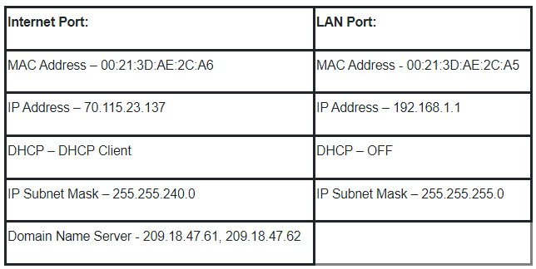

a. Media Access Control (MAC) addresses are used for a number of extremely important factors in digi-space. Primarily, it is used in order to identify specific devices from one another in order to aid in organization and security of technological ecosystems (Ohio State University, 2021). For this reason, the two MAC Addresses are each denoting single network interfaces. The Internet and LAN ports of a router are two separate network interfaces, and thus require two separate MAC Addresses.

b. As an essential feature of internet protocols, IP addresses are used for communication in today’s global internet. IP addresses come in two forms; Internal and Public (Northwestern University, 2019). A local IP Address (Internal) is used by devices within your local group, or LAN. An External (Public) IP Address is used by devices other than those on your LAN. In the table above, the router would have a local IP Address of 192.168.1.1 and an external IP Address of 70.115.23.137.

2. Dynamic IP assignments have a number of advantages (Moes, 2022). Firstly, they are relatively easy for the consumer to work with. Being the default for DHCP architecture, there is no need for a consumer running their personal laptop to work with advanced networking topics like Port Forwarding in order to simply send emails, or browse the internet. All of that is done automatically and instantaneously. Secondly, it is much simpler to add new devices to your network with Dynamic IP’s. In order to add a new device with a Static IP network configuration, you would need to manually remove a device that may have used that IP in the past. Dynamic IP’s may be reused at will with the technical tinkering being done by your ISP. There are some disadvantages to using Dynamic IP assignments, however (Moes, 2022). Firstly, Dynamic IP’s make server structure much more complicated. In order for other devices to be able to connect to your server, the server must have a pre-established IP to communicate to. This communication is much more difficult and much less effective should the IP be constantly changing. Secondly, the features associated with Dynamic IP addresses would make it much more difficult to reliably communicate between devices to perform remote hosting for businesses, or technological hobbyists.

3. A number of services have been implemented in order to make sure online communications run smoothly enough for the high demand of today. One such service would be World-Wide Web. This service is an information system letting the user access the vast informational library of the internet using protocols such as HTTPS, FTP, E-mail and much more through hypertext libraries (The University of Oklahoma, n.d.). A second service that is essential for operation in today’s Netscape would be DHCP. Talked about earlier in Question 2, DHCP is a network protocol architecture that allows an ISP to automatically and instantaneously assign dynamic IP’s to devices that connect to a network (Moes, 2022). This is particularly useful to eliminate some of the hassle and error instances when involving complex networks, and consumer-level interactions in which cases Static IP addresses may be more complicated to diagnose and work with than the governing authority has resources or time for. A third service may be something you use regularly without even knowing it. File Transfer is a series of protocols that dictate how large blocks of data are sent and received in a network through Sever Message Block (SMB) and File Transfer Protocol (FTP) (The Open University, 2023). This is distinctly different from services like Google Drive, as those use this File Transfer service in order to operate, and are not mutually exclusive. A fourth service would be directory services. This is a directory that lists information about companies, customers, and additional information pertaining to business (geeksForGeeks, 2022). This is useful to access Domain Number System (DNS) information of your business to get a comprehensive readout of devices and printers registered to your network.

4. A globalized website has many advantages to it. Firstly, you gain access to a myriad of different customers. These new customers may help drive your business’ revenue stream much further than before. A second advantage is that these new customers come with their new markets. This gives a phenomenal boost to options within your business, as a product that fails in one market may find success in another, and save your business from a complete loss in profit. There are difficulties involved with globalization, however. Firstly, for each new market you plan to expand to, careful strategy is required. Businesses will need to ensure they can effectively communicate with the residents of their new market.

# **References**

geeksForGeeks. (2022, June 10). *Internet and its Services*. Retrieved from geeksforgeeks.org: https://www.geeksforgeeks.org/internet-and-its-services/

Moes, T. (2022, September). *Static vs Dynamic IP Address: What’s the Difference?* Retrieved from SoftwareLab: https://softwarelab.org/static-vs-dynamic-ip-address/

Northwestern University. (2019, February 4). *Locating your IP address*. Retrieved from Northwestern IT: https://kb.northwestern.edu/page.php?id=69163

Ohio State University. (2021, January 16). *What's a MAC Address and how do I find it?* Retrieved from OSU.edu: https://slts.osu.edu/articles/whats-a-mac-address-and-how-do-i-find-it/

The Open University. (2023, January 3). *Using and Understanding Internet Services*. Retrieved from open.edu: https://www.open.edu/openlearncreate/mod/oucontent/view.php?id=129586&printable=1

The University of Oklahoma. (n.d.). *World-Wide Web*. Retrieved from ou.edu: https://www.ou.edu/research/electron/internet/www.htm